

THE HERITAGE

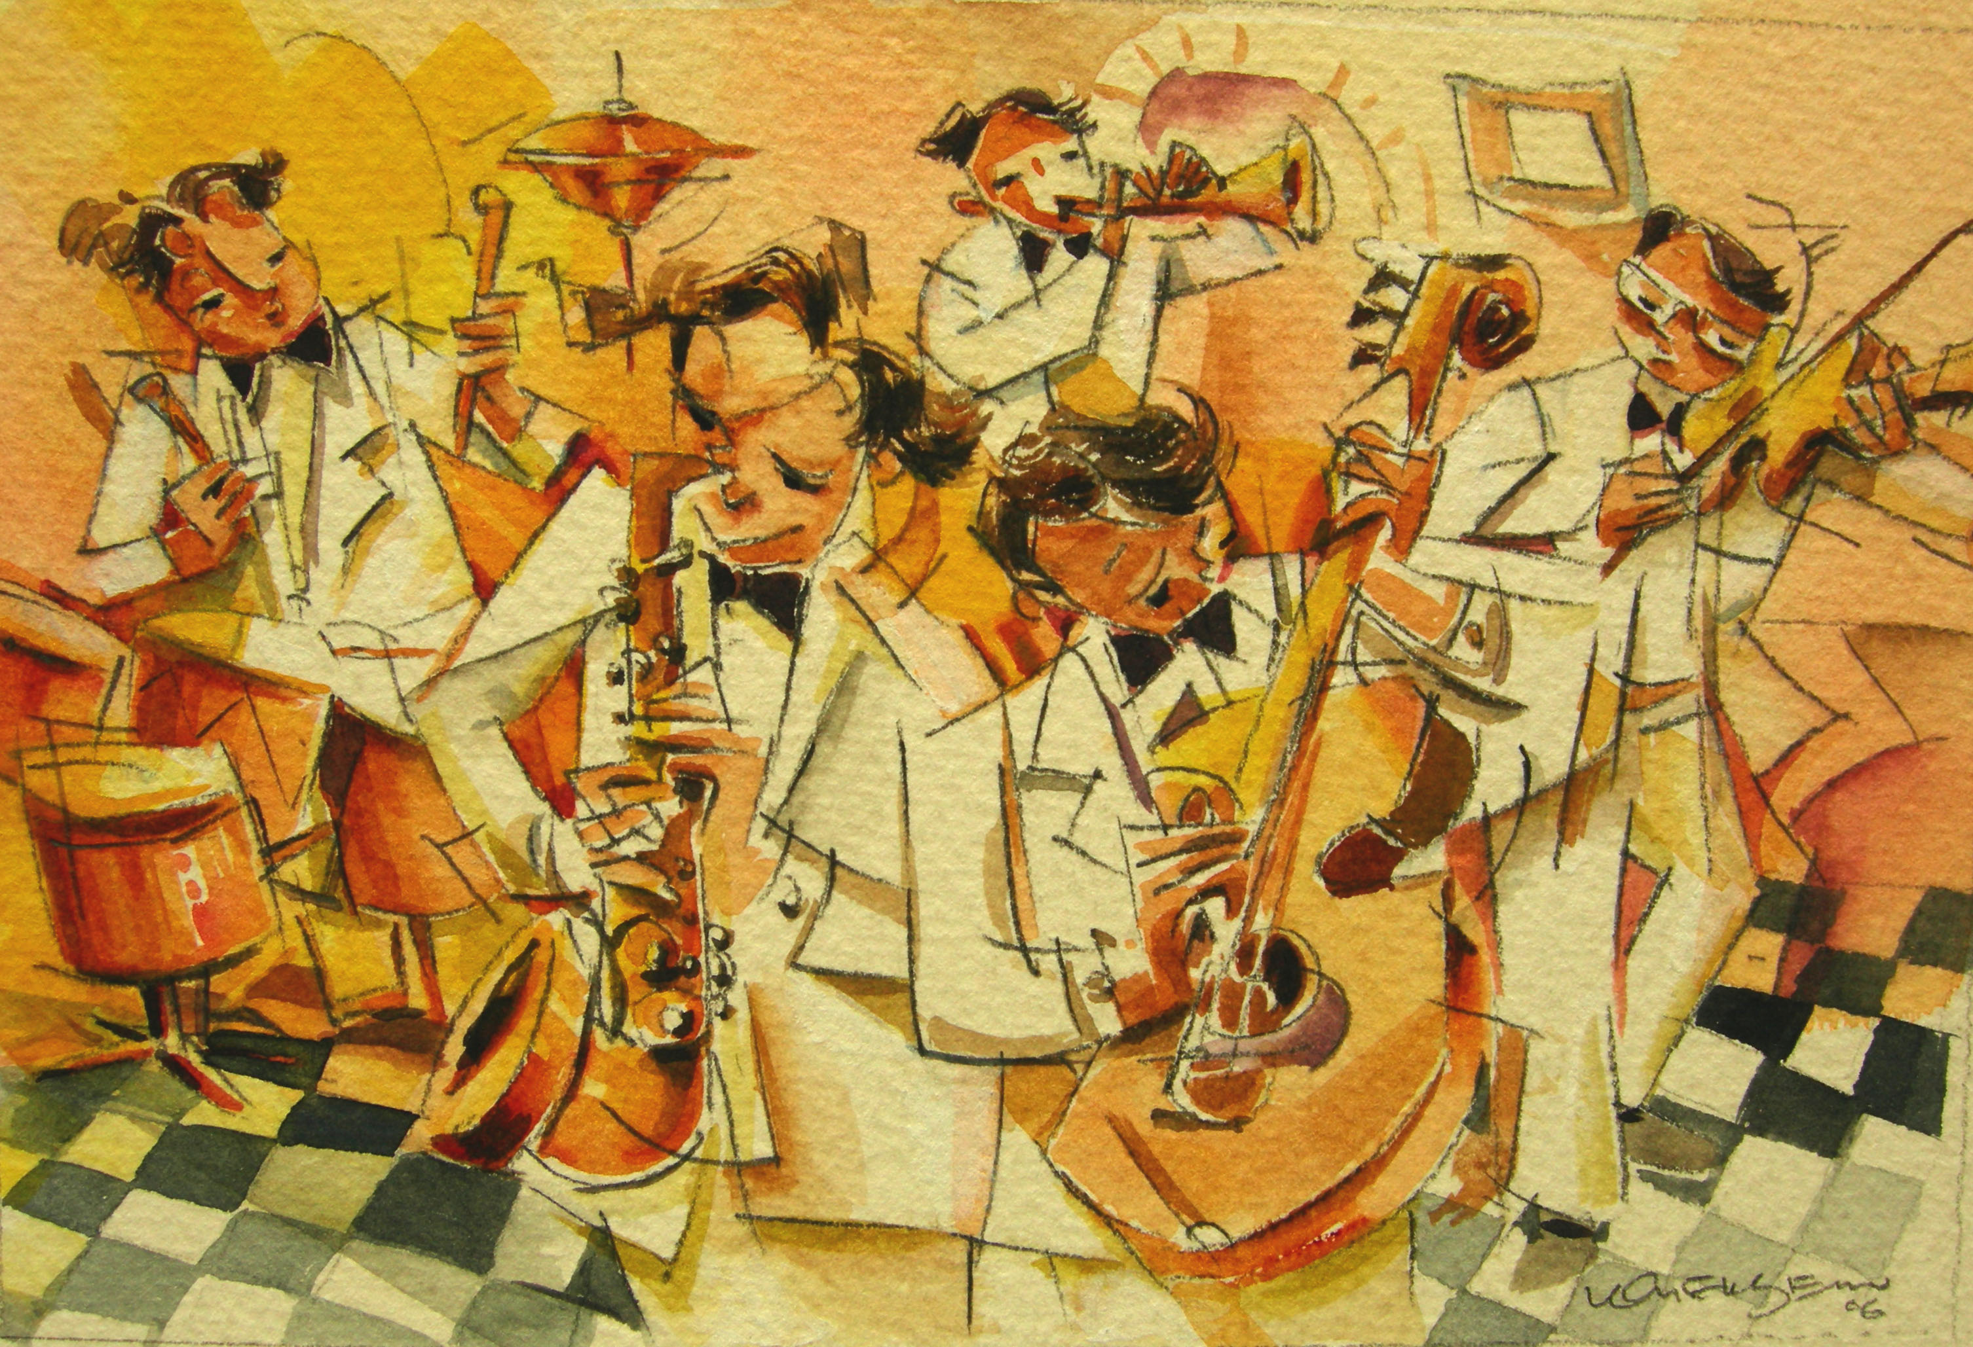
Jazz Bands
To many, it seems as if the Peranakan attempted to live the British lifestyle as much as possible. They sought work in British-owned companies, collected works of art, decorated their homes in European style and even formed jazz bands.

